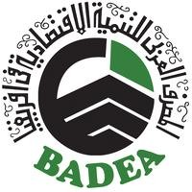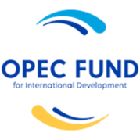 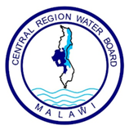

CENTRAL REGION WATER BOARD (CRWB)

**NOTIFICATION OF INTENTION TO AWARD CONTRACT**

**Date of Issue: 04th September 2023**

Central Region Water Board (CRWB) wishes to inform the General Public and bidders that participated in the tender for Consultancy Services for Design Review and Construction Supervision for Dowa Town Water Supply and Sanitation Project, in line with clause 48 of the Public Procurement and Disposal of Assets Act No 27 of 2017, that it has concluded the bid evaluation process and intends to award contract referred to above as follows:

**PRJECT ID No: P-MW-E00-011 CONSULTANCY SERVICES FOR DESIGN REVIEW AND CONSTRUCTION SUPERVISION FOR DOWA TOWN WATER SUPPLY & SANITATION PROJECT**

|  |  |  |  |
| --- | --- | --- | --- |
| **Lot No.** | **Description** | **Contractors** | **Amount in USD** |
| 1 | **Consultancy Services for Design Review and Construction Supervision for Dowa Town Water Supply & Sanitation Project** | ECG-Engineering Consultant Group S.A in Association with John Kandulu and James Mambulu trading as BAWI Consultants | USD 1,652,000.00 |

Unsuccessful bidders who wish to request for a debriefing session may submit their request in writing to the address below before **Monday 18th September 2023**

**The Chairperson,**

**Internal Procurement & Disposal of Asset Committee,**

**Central Region Water Board,**

**Area 4, Murray Road,**

**Off Paul Kagame Road,**

**Opposite Immigration Offices,**

**Private Bag 59,**

**Lilongwe,**

**Malawi.**

**Email: cwrb@crwb.org.mw**